Revised 4/24/2008
Overview:
This file contains all changes to the Biotics Tracker database schema, data content, and security configuration made between 08/02/06 and 03/11/08. Instructions for running this script are included below. You must apply this patch to your database in order to have the most current database configuration.

If you have any questions regarding this patch or the nature of the changes, submit an issue to the product support database. Please reference the specific patch component that you have questions about.

Because of the diverse nature of the changes in this patch, it has been divided into several components. Each component is independent of the others, meaning that you can perform them in any order. No users should be in the system when the patch is being run.

Depending on when your program was installed with Biotics 4, you may already have some of these changes in your database. As each of these changes was performed on the Central production database, they were incorporated into all subsequent data conversions and installations. The patches have been constructed so that they can be run even if the items to be changed have already been changed. For example, if you already have the new index IMPORTED_AUDIT_ID1, you will get an “ORA-00955: name is already used by an existing object” message when you run this patch. This is simply telling you that the index already exists in your database, so you can ignore this message. Any other error messages should be investigated before going any further. Search for the string “ORA-“ to find errors in the log file.

If you are in the middle of your data exchange, you can go ahead and install Patch 10 before you upload your data. You do not need to wait until after uploading to install Patch 10.

If you are still running an old version of Tracker (1.7.12 or 1.7.12), you should still install Patch 10. You do not have to wait until you upgrade to 2.3.7 before installing the patch, nor will you have to rerun the patch once you upgrade.

Before performing any of these changes, you should do the following:
- Read through these and any other accompanying instructions carefully
- Back up your database, or have done so in the recent past
- Run any other Biotics patches that may be needed in your database. If you are unsure as to which patches have been run in your database, please refer to the KnowledgeBase folder Biotics Tracker 4\Patches and read the card titled ‘How can I tell which patches I need to apply?’

#1. Biotics_update_0010_del.sql: This patch contains several changes to the both the regular and the deleted database schemas. The first step will be to make the changes to the deleted schema. This script can be run directly in SQL+ by a data administrator. You must be logged in as biotics_del or whatever the name of your deleted schema is, not as sys or system. You cannot run this script logged in as the biotics_user.

Please note that this script should be run in SQL+, not the SQL+ Worksheet.
Run the script with the following command:

@<path name for file>\biotics_update_0010_del.sql

The script will automatically spool the output to a file named biotics_update_0010_del.log so that you may review any errors. You will be prompted to supply the path for that file ('Enter path for scripts and update log w/o last back slash):'

Once the script has finished execution, open the spool file and make sure everything was performed without errors.

#2. Biotics_update_0010_reg.sql: This script can be run directly in SQL+ by a data administrator. You must be logged in as biotics_user, not as sys or system. If you are logged in as biotics_del or system, you must log out and log back in as the biotics_user in order to run this script.

Please note that this script should be run in SQL+, not the SQL+ Worksheet.
Run the script with the following command:

@<path name for file>\biotics_update_0010_reg.sql

The script will automatically spool the output to a file named biotics_update_0010_reg.log so that you may review any errors. You will be prompted to supply the path for that file ('Enter path for scripts and update log w/o last back slash):'

The changes in this script are listed as follows:

Item | Description
BT4774 | Increase field size in COMM_CAL_MAP_UNIT.map_unit
BT4796 | Increase size of Observer field in OBSERVATION table
TT3336 | Add fields to MANAGED_AREA_VIEW and SITE_VIEW to make them consistent with what Designer calculates and what appears in the shapefile.
BT5813 | Correct entries in HDMS_TABLE_ACTIONS for new tables OTHER_EGT_ID, OTHER_ENT_ID, OTHER_EST_ID
Bt4376 | Update and add values to D_TNC_ECOREGION table
BT6027 | Add new domain value to D_FWS_ECOREGION
BT5077 | Correct security configuration for new SOURCE_FEATURE fields.
BT6066 | Make usesa functions case insensitive
BT6074 | Put a constraint on the EO.data_sensitive_eo_ind field to restrict it to just Y or N.
Bt6199 | Delete stray asterisks in some D_NUMBER_PROT_EOS values.

Once the script has finished execution, open the spool file and make sure everything was performed without errors.

One of the scripts in this package will synchronize the values in your D_TNC_ECOREGION table with the values that are in the Central Production database. Your database may already have many of the new values in this script. Don’t be alarmed if you see errors in your log that look like this:

ERROR at line 1:
ORA-00001: unique constraint (BIOTICS_USER.D_TNC_ECOREGION_AK1) violated

This is just Oracle’s way of telling you that you already have these values in your database. You can ignore these messages completely.

If your spool file contains a message that looks something like this:
Invalid indicator found for EO 9 Data_sensitive_eo_ind = A
It means that the last script in the patch was not allowed to execute. Script bt6074.sql will put a constraint on the data_sensitive_eo_ind field in the EO table that will limit its values to either ‘Y’ or ‘N’. It will first query the database for any EOs that would violate this constraint. If any are found, the eo_id and the value found for that field will be displayed in the spool file. You will need to correct these values in your database and rerun the patch in order to add the constraint to your database.

#. Cleanup: After performing the database changes, you must recompile objects that have become invalid. To identify and recompile ALL database objects that may have become invalid, perform the following steps:

- Logon to SQL+ as the regular schema user, which is usually biotics_user. You must be in SQL+, not the SQL+ Worksheet.

- At the SQL> prompt, enter:

@<path name here> check_invalid.sql

You will be prompted to provide the path for that file.

The script will create a new script named recompile_invalid.sql, place it on the path that you have designated, and will then automatically run that script.

- Once the file has completed running, check to see if any invalid objects remain. Enter the following query:

select count(*) from user_objects where status = 'INVALID';

If you receive any number greater than 0, repeat Step 2. You may need to run this script several times in order to compile all invalid objects.

You may see an error like the one pictured below. This error can be ignored. The last step in the recompile_invalid file is a command to turn the spooling off. When the file is executed, SQL+ attempts to execute this command as well and takes an error. It does not affect the recompiling of any invalid objects.
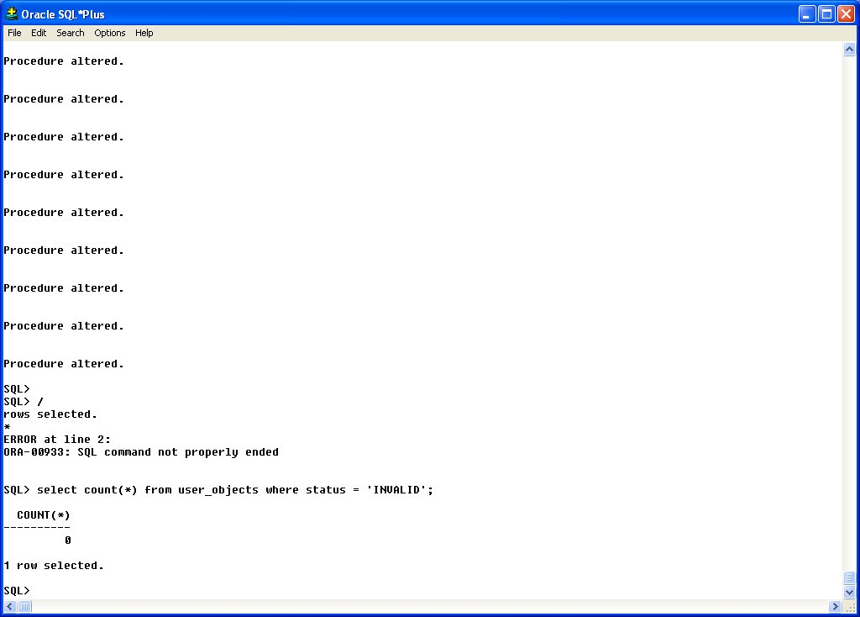

If you have any objects that can’t be compiled or any other types of error messages, contact Product Support by opening an issue in the Product Support database. Be sure to attach the output log to the item.

When you have no more invalid objects, you should rebuild the database statistics so that you will have optimum performance. Run the following lines in SQL+:

Logged on as the biotics_user, enter:
exec dbms_stats.gather_schema_stats (ownname => 'BIOTICS_USER', cascade => true);

Logged on as the biotics_del user, enter:
exec dbms_stats.gather_schema_stats (ownname => 'BIOTICS_DEL', cascade => true);

Depending on the size of and level of activity in your database, the above statements could take anywhere from 2 to 45 minutes to run.

And don’t forget:
To note in your database maintenance log the date that you ran this Patch!

