Companion Handout to 'Element Concept Training'
Leah Oliver, NatureServe, Nov. 2006

Contents:
- Access information to the zoological and botanical nomenclatural codes
- Additional help on Element Concepts and taxonomic updates
- How the records for the Lythrum taxonomic update example would really look in the central Biotics.

I. International Code of Zoological Nomenclature (ICZN): http://www.iczn.org/iczn/index.jsp
International Code of Botanical Nomenclature (ICBN): http://www.bgbm.fu-berlin.de/iapt/nomenclature/code/SaintLouis/0000St.Luistitle.htm

II. The presentation and activities from today's talk are posted on the Biotics public website, under 'Support'. http://www.natureserve.org/prodServices/biotics/biotics-support.shtml

The following are posted on the Biotics public website under 'Element Concept Training':

Element Concept Training power point
Element Concept Training handout – this doc
Element Concept Training Activities – taxonomic examples
Guidance on Adding or Replacing Elements in a Heritage Biotics Database (The original document is posted in the Knowledge Base under Biotics 4 Tracker, Element Tracking.)

- Central Biotics records for the Lythrum taxonomic update example from presentation

Below you'll see how the Element Global records would look in the central Biotics for the L. salicaria taxonomic update case used throughout the presentation.

1) Element global record for Lythrum salicaria record, sensu lato

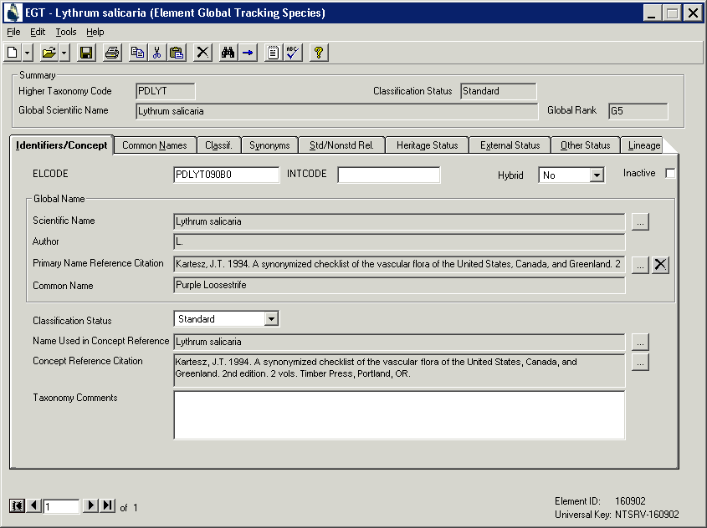

This is the element record for L. salicaria without any material split from it.

2) Element global record for Lythrum salicaria var. glabrum (= L. intermedium)

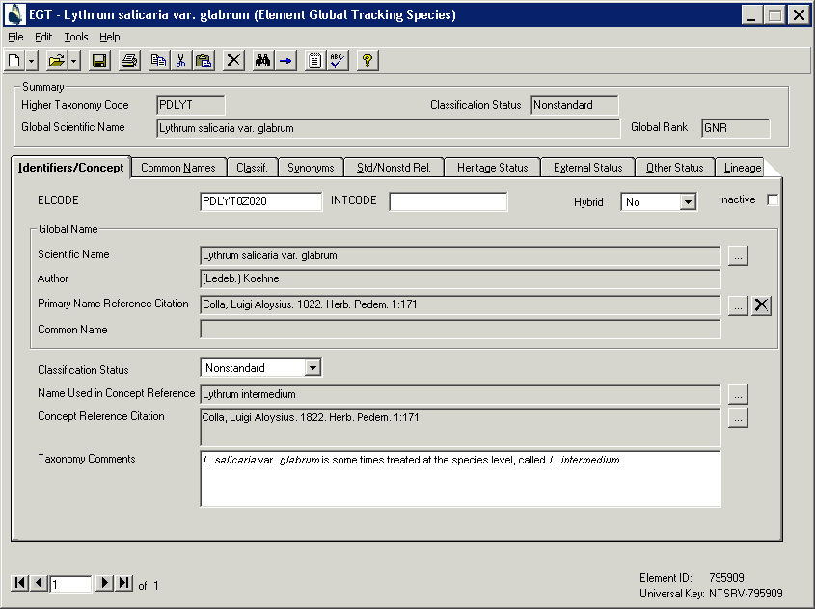

L. intermedium is split from L. salicaria in Colla, Luigi Aloysius. 1822. Herb. Pedem. 1:171; this is used as the concept reference. Later, this taxon is subsumed back into L. salicaria and called L. salicaria var. glabrum. Note that L. salicaria var. glabrum is the Global Scientific Name, and the 'Name Used in Concept Reference' is Lythrum intermedium. The Global Scientific Name can be updated, but the Name Used in Concept Reference should remain the same for the life of the element record. These two names, L. intermedium and L. salicaria var. glabrum are nomenclatural synonyms. See the next page.

Global synonyms grid for L. salicaria var. glabrum: We try and only enter nomenclatural synonyms in the Global synonyms grid, i.e. names that refer to the same type and material, however, in the Subnational synonyms grids member program can maintain any synonymy they wish, including heterotypic synonyms. The Subnational synonyms grid is not exchanged during the data exchange.
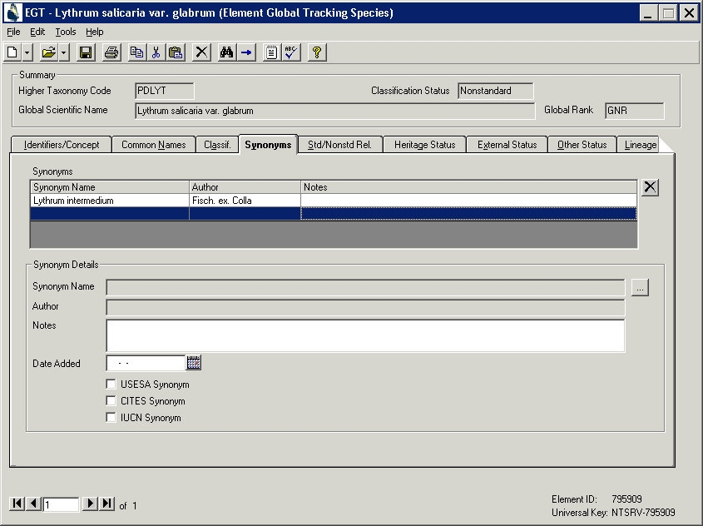

Here's an EST for Lythrum salicaria var. glabrum. Notice that the Subnational Scientific Name is Lythrum intermedium. Also, the Concept Reference and the Name Used in the Concept Reference are shown in every EST.

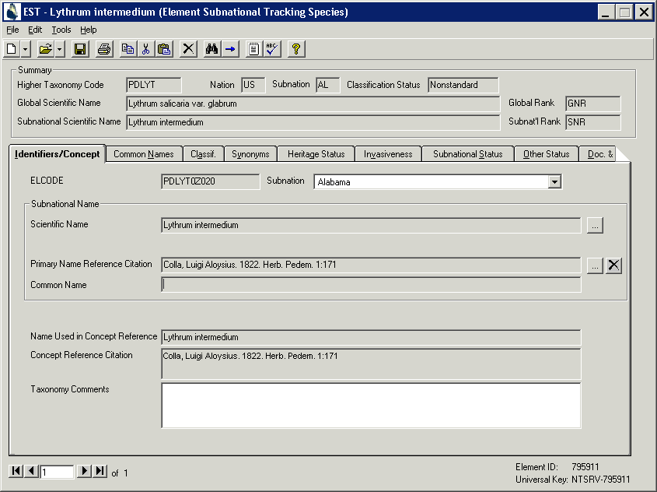

3) Lythrum salicaria record, sensu stricto

This is the new Lythrum salicaria excluding L. intermedium. Note the 'Name Used in the Concept Reference' and the 'Concept Reference'. The Taxonomy Comments should be filled out to explain how this taxon relates to the other taxon with the same name.

