INTRODUCING THE USNVC

A Federal Standard

Background (from usnvc.org).

Partnerships – Inter-agency and Organizational Support.

History of development of the NVC and all the partners over the years and currently.

The Hierarchy

Reference four examples for introduction; to be built upon later; intro to natural-to-cultural continuum…

Classification Development

Plot data, sampling design, analysis, databases, reference sites, peer-review, etc.

Current Content

What is the current status of NVC- numbers of units, where it is served on-line.

Publications and Products

Multiple products, websites, access to descriptions, relevant reports and papers.

Contents

D-1 INTRODUCTION 2

D-2 INTRODUCING THE USNVC 4

D-2.1 A Federal Standard 4

D-2.2 Partnerships – Inter-agency and Organizational Support. 4

D-2.3 USNVC: Classification Basics 5

D-2.4 Principles 1 - 3: Existing Vegetation, Floristics & Growth Forms, Natural & Cultural 6

D-2.5 Principles 4 - 6: Plot Data, Type Concepts, and Mapping 9

D-2.6 Principles 7 - 8: The Ecological Vegetation Hierarchy. 14

D-2.7 Principle 9: Classification Development - Peer Review and Vegetation Plot Data 19

D-2.8 Current Content 20

D-2.9 Publications and Products 23

Websites 23

Publications [incomplete] 23

* 1. INTRODUCING THE USNVC
     1. A Federal Standard

Classifying and describing vegetation is critical to sound ecological science and efficient land assessment, management and planning. For that reason, the Federal Geographic Data Committee created a Vegetation Subcommittee to develop the U.S. National Vegetation Classification (NVC) Standard (FGD 2008). This Standard now guides the development of the NVC, a central organizing framework for how all vegetation in the United States is inventoried and studied, from broad scale formations (biomes) to fine-scale plant communities. The Standard is driven by this **vision**:

*The Vegetation Classification Standard enables federal agencies to produce uniform statistics about vegetation resources across the nation, facilitates interagency cooperation on vegetation management issues that transcend jurisdictional boundaries, and encourages non-Federal partners to utilize and contribute to a common system when working with their Federal partners.* (FGDC 2008).

Thus, the NVC provides a comprehensive view of the nation’s terrestrial ecosystems at multiple scales, irrespective of jurisdiction or agency. In this way, users are able to systematically monitor and inventory the nation’s vegetation, compare status and trends, and address management and conservation needs.

* + 1. Partnerships – Inter-agency and Organizational Support.

**History**

The NVC has been a work in progress since 1997, when the Federal Geographic Data Committee (FGDC) Vegetation Subcommittee approved the National Vegetation Classification Standard (FGDC 1997). The FGDC Vegetation Subcommittee (chaired by the U.S. Forest Service) oversees a three-pronged partnership, which includes federal agencies, the Ecological Society of America (ESA), and NatureServe. Together they have deliberated on everything from the hierarchy structure to consistent terminology, and they devised screening and peer-review protocols to build and revise the NVC. The original 1997 (“version 1”) of the NVC hierarchy proved unworkable (see Faber-Langendoen et al. 2009), which led in 2008 to a revised Standard, with a new hierarchical approach and a peer-review based process for developing the NVC content (FGDC 2008). The revised standard required a substantial amount of revision to the original NVC content, and it wasn’t until February 2016 (<http://usnvc.org/>) that a fully functional version 2 was released. But it is already widely adopted by state and federal agencies, because it addresses earlier shortcomings and offers the benefits of consistent and dynamic content (ESA Vegetation Classification Panel 2015).

The inspiration for creating this uniform classification system, as recently summarized by Watts (2016), dates to the late 1980s when The Nature Conservancy realized it needed a nationally consistent vegetation classification for its conservation work. However, at that time numerous alternative vegetation classification systems were employed by different federal agencies, states, non-profits and academic groups. This started to change in 1994 when three things happened. First the FGDC Vegetation Subcommittee was formed and began working to create a standardized vegetation classification for use by federal agencies. Second, it was agreed that a quantitatively-based national vegetation classification was needed to provide a common language for the broad user community, which led ESA to start the Panel on Vegetation Classification. Third, NatureServe (then part of The Nature Conservancy) agreed to put its ecological expertise, data management skills, and the Network of state ecologists to support the use of the NVC as a federal standard (Grossman et al. 1998). Thus, the FGDC Vegetation Subcommittee became the vehicle that facilitated broad collaboration among the many parties interested in its continued development.

A number of federal agencies invested early in the application of the NVC to their inventory, assessment and mapping programs. These included the Fish and Wildlife Service, which supported the identification of the rarest plant communities in the U.S (Grossman et al. 1994); and the National Park Service (NPS) and the U.S. Geological Survey National GAP Program, which both recognized the value of a national classification to guide standardized vegetation maps, whether for all major park units, in the case of NPS (REF), or for the entire country, in the case of the national GAP program (Jennings 2000). The success of these early projects lent further support to the development of the NVC.

* + 1. USNVC: Classification Basics

The NVC follows the EcoVeg approach to classification (Faber-Langendoen et al. 2014). The EcoVeg approach is also used by the Canadian National Vegetation Classification (Baldwin and Meades 2008) and the International Vegetation Classification (NatureServe). Together these classifications provide a global framework for all broad-scale ecosystems (Faber-Langendoen et al. (2016), and a comprehensive set of mid-scale types for all of North and South America (Faber-Langendoen et al. 2017).

The USNVC and the EcoVeg approach are guided by nine core principles, briefly summarized here and further explained below (see also FGDC 2008, section 1.6.1):

1. The classification is based on *existing vegetation* types, defined as the plant cover − including both floristic composition and vegetation structure − documented at a specific location and time, under specified ecological conditions, and preferably described at an optimal time during the growing season.
2. Vegetation types are characterized by *full floristic* and *growth form (physiognomic)* composition, which together express *ecological* and *biogeographical* relations.
3. Vegetation characteristics are the product of *natural* and *cultural (or anthropogenic) processes*.
4. Characterizing and describing vegetation types is best accomplished using *plot data* that includes both vegetation and environmental site data, which are collected and compiled using *systematic protocols and survey techniques.*
5. Vegetation types are defined using a *number of differentiating criteria*, including diagnostic, constant and dominant species, dominant and diagnostic growth forms, and compositional similarity. The most useful criteria are those that express *ecological* and *biogeographical relationships* and that clearly distinguish types. These criteria should be defined for application in the field or lab, so that *recognizable field characteristics* are providedto ensure consistent identification using keys and other tools.
6. Classification and field recognition of vegetation types creates a conceptual framework for vegetation pattern and process that provides a foundation for, but is distinct from, *vegetation mapping*.
7. Differentiating criteria for vegetation types can be arranged *hierarchically,* from *upper levels* primarily based on general growth forms, to *middle levels* based on specific growth form and floristics that includes suites of general and regional combinations of characteristic species, and *lower levels* based primarily on regional to local floristics. At all levels, vegetation provides the primary criteria for descriptions within the hierarchy, but the organization may be based on the ecological and biogeographical relations expressed by the vegetation.
8. An integrated hierarchy of vegetation types is best established by considering *each level as both independent and inter-connected* in a *nested* relationship; that is, each level contains clearly specified vegetation and ecological criteria to allow users to assign types to that level, while using upper and lower levels to inform those levels. Thus the USNVC is developed through both “top-down” and “bottom-up” analyses.
9. The classification is best maintained through a coordinating body that oversees the recognition and integration of new and revised classification units, through a peer-review process. The goal is that at any one time there will be one set of vegetation types that represent the best current understanding of the nation’s vegetation.

The principles outlined above have guided the overall development of the USNVC. Other considerations in the development of the USNVC (FGDC 2008) are that a) the classification shall avoid developing conflicting concepts and methods through cooperative development with the widest possible range of individuals and institutions, b) application of the classification shall be repeatable and consistent, and c) where possible, the classification standard shall use common terminology (i.e., terms should be understandable and jargon should be avoided). These have all helped ensure that the USNVC is based on national and international standards, is consistent across all types, and is as user-friendly as possible. We explain each of the principles in more detail below.

* + 1. Principles 1 - 3: Existing Vegetation, Floristics & Growth Forms, Natural & Cultural

*Vegetation is the plant cover of an area, defined as all vegetation with ≥ 1% surface coverage with live vascular and non-vascular plant species, including wetland vegetation (rooted emergent, rooted submergent and floating aquatic vegetation).*

*Existing Vegetation*

The USNVC includes only existing vegetation types; that is, the plant cover, or floristic composition and vegetation structure, documented to occur at a specific location and time (Tart et al. 2005a, Jennings et al. 2006). It is the vegetation that represents conditions as they exist today – what a land manager finds on the ground and deals with on a daily basis (Powell 2011) (Fig. 1). The USNVC Standard does not directly apply to classification or mapping of potential natural vegetation (the vegetation that occurs if all successional sequences were completed, without interference by humans, under existing environmental conditions) (Powell 2011), except in so far as that vegetation currently exists on the landscape. For example, the potential vegetation of a site may be open sage steppe, and that vegetation currently exists on the site.

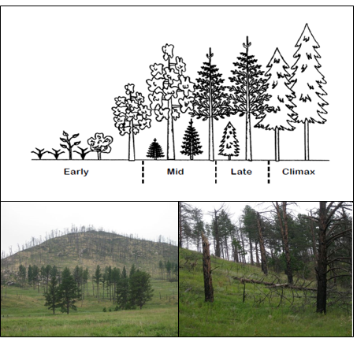

FIGURE 1. a) Seral stages for a forest type (from Powell 2011). In the USNVC, each stage is described, and may or may not belong to the same “climax plant association;” e.g., the early grass-shrub dominated stage may be an association in a non-forest class (Shrub & Herb Vegetation). The grass-shrub stage (lower left), although often of short duration, may persist for many decades after high severity forest fires, such as occurred in the 2000 Jasper fire in the Black Hills of South Dakota, where, in high severity burn areas, ponderosa pine regeneration is absent 11 years after the fire. Photo. D. Faber-Langendoen (see also Keyser et al. 2008).

*Natural and Cultural Vegetation*

One of the more distinctive features of the USNVC is that it includes both natural vegetation, which establishes spontaneously and is shaped partly or strongly by ecological processes, and cultural vegetation, which is typically planted and strongly shaped by anthropogenic processes, e.g., corn fields or golf courses) (Fig. 2). By including all vegetation types in a consistent framework, land managers and others can address issues such as wildfire regimes, pest infestations, exotic species invasions, successional changes, and conversion to farms or homes. In addition, the comprehensive approach of the USNVC classification enables an ‘all lands approach,’ which several government agencies use to ensure that their agency-specific land management planning takes place in the context of the larger landscape.

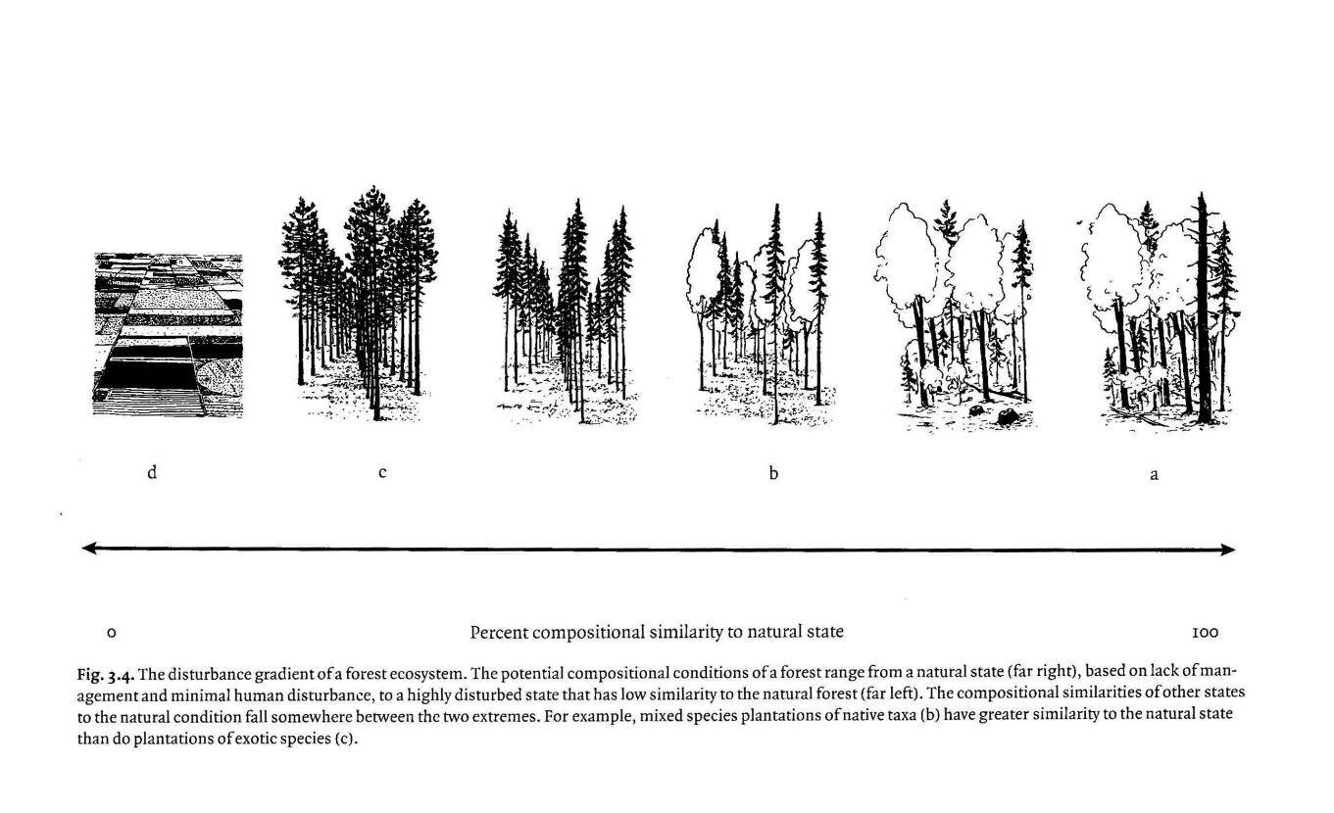

FIGURE 2. The disturbance gradient of ecosystems, indicating the full range of natural to cultural vegetation. Forest conditions range from a natural state (a, far right), based on ecological processes and minimal human disturbance, to a cultural state (d, far left), based on human planting and processes. Mixed species plantations of native taxa (b), with some natural regeneration, have greater similarity to the natural state than do more manipulated plantations (c). These plantations are managed in tight rows and exclude native regeneration, and are sufficiently unlike natural stands as to be a form of cultural vegetation (d). Adapted from Palik and Engstrom 1999, Fig. 3.4. Used with permission from Cambridge University Press.

**Natural vegetation** is composed predominantly of spontaneously growing sets of plant species with composition shaped by both abiotic (site) and biotic processes; these are vegetation types whose species composition is primarily determined by non-human ecological processes (Küchler 1969, Westhoff and van der Maarel 1973, van der Maarel 2005). Although natural vegetation is variously affected by human activities (e.g., logging, livestock grazing, fire, introduced pathogens), it retains a distinctive set of spontaneous vegetation and ecological characteristics (Westhoff and van der Maarel 1973, Di Gregorio and Jansen 1996). It includes both near-natural and ruderal vegetation (see below).

**Cultural vegetation** possesses a distinctive structure and composition that is determined by the response to human intervention(cultural vegetation *sensu stricto* Küchler 1969, Di Gregorio and Jansen 1996). Characteristics of cultural vegetation are 1) regularly spaced herbaceous vegetation with substantial cover of bare soil for significant periods of the year (usually determined by tillage, chemical treatment, or agricultural flooding), 2) vegetation consisting of highly-manipulated growth forms or structures rarely found under natural plant development (usually determined by mechanical pruning, mowing, clipping, etc.), 3) vegetation composed of species not native to the area that have been intentionally introduced to the site by humans and that would not persist without active management by humans (e.g., arboretums).

*Ruderal Vegetation*

Within the broad concept of natural vegetation, there is growing interest in the more distinctive invasive and weedy vegetation types; that is, those with no apparent historical natural analogs, sometimes referred to as “novel” or “emerging” ecosystems (Hobbs et al. 2006, Belnap et al. 2012) (Fig. 3). We refer to this vegetation as ruderal; that is “vegetation found on human-disturbed sites, with no apparent recent historical natural analogs, and whose current composition and structure (1) is not a function of continuous cultivation by humans and (2) includes a broadly distinctive characteristic species combination, whether tree, shrub or herb dominated.  The vegetation is often comprised of invasive species, whether exotic or native, that have expanded in extent and abundance due to human disturbances” (Curtis 1959, Ellenberg 1988, Lincoln et al. 1998). For example, after intensively farmed field are abandoned in eastern North America, an old field vegetation types forms that contains a mix of “weedy” native shrubs (e.g., *Cornus foemina*), exotic invasive shrubs (e.g., *Rhamnus cathartica* and *Lonicera spp.*), and a variety of native and invasive forbs, which together have no analog to the former and surrounding historic native forest vegetation in the region. Land managers often face complex decisions regarding management of these types; for example, whether to reduce or eliminate invasive types that lower or ruin pasture or range productivity, or to promote types that may help stabilize slope or bank erosion.



FIGURE 3. A conceptual framework for describing near-natural (“wild”), ruderal (novel) and cultural (intensive agriculture) ecosystems. Hash marks represent thresholds where ecological processes change, begin or are lost from the system. Upper arrows indicate ecological dynamics or human activities controlling possible return pathways.

* + 1. Principles 4 - 6: Plot Data, Type Concepts, and Mapping

*Plot Data*

Plot data are to a vegetation ecologist what voucher specimens are to plant taxonomists or soil pits to a soil scientist (Fig. 4). They provide the core data used to analyze and characterize types. By the same token, just as plant taxonomists use additional information, such as breeding biology and behavior, to further clarify species concepts, so to vegetation ecologists use information on environmental site data, ecological drivers, and stand dynamics to clarify vegetation type concepts.

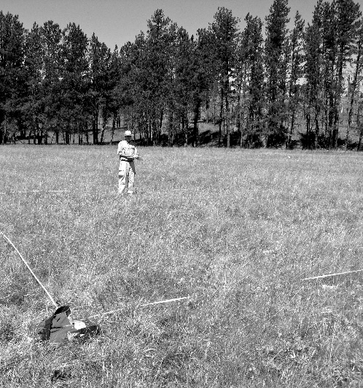 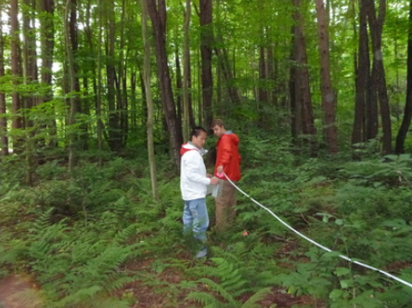

FIGURE 4. Vegetation plot sampling.

Vegetation plot records are made available either by conducting field surveys or by accessing them from available vegetation-plot databases, which may be available from state or federal agencies, organizations, universities or independent researchers. A fundamental concern when classifying vegetation is that plot records span as wide a range of geographical and environmental variation as possible across the hypothesized range of a type.

To support the USNVC, a public vegetation plot database (VegBank; http://vegbank.org) was launched in 2004 (Peet *et al*. 2012). The purpose of archiving these records is not only to document the USNVC types but to help with other objectives, including monitoring ecological condition, mapping, and contributing to ecological site descriptions. Other databases may also be used to support the USNVC, provided records are publicly available and accessible (much as herbarium specimens are open to anyone wishing to review a species concept).

Plot data should be collected using broadly comparable plot sizes, from 100 - 1000 m2, in order to adequately characterize vegetation structure, species diversity and dominance. The minimum total plot size of 100 m2 is suitable for most vegetation types, with smaller-scale patterns considered part of “within-community variation” (Peet and Roberts 2013). Some types, such as temperate forests, may require 400 m2 plots, and tropical forests or deserts even larger plot sizes. Comparability among vegetation types is facilitated by using a nested plot design, in order to maintain one or more plot sizes across structural types (e.g. forests and grasslands). For example, the Whittaker plot design (see Peet et al. 1998, Keeley and Fotheringham 2005) includes a number of widely used plot sizes (1 m2, 10 m2, 100 m2, 400 m2, 1000 m2), and thus this single plot design can be used for most all vegetation types (Fig. 5). At minimum, a single 100 m2 plot size can be sampled within a larger plot and, if desired, as an aggregate of smaller plots or quadrats, depending on the vegetation type. An additional advantage of the Whittaker plot design is that it can be used in conjunction with a variety of transect designs (Stohlgren et al. 1998).

Where multiple plots smaller than 100 m2 are used on their own to characterize a stand (e.g., multiple 1 m2 to 10 m2 quadrats), they should be aggregated, because the combined data are more accurate for characterizing the diagnostic, constant and dominant characteristics of a stand (note, however, that species richness per unit area can only be approximated at this aggregated scale if the quadrats are not directly next to each other). For further guidance on plot size and design, see Peet and Roberts (2013).

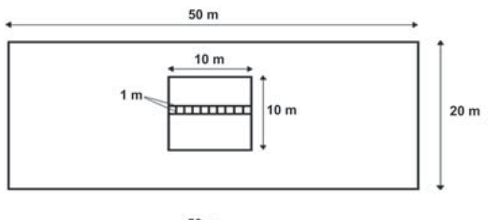

FIGURE 5. The original nested plot design of Whittaker (Shmida 1984), showing ten 1 m2 quadrats, 10m2 (1 x 10 m), 100 m2, and 1000 m2 plots (image from Keeley and Fotheringham 2005). A 400 m2 plot size is also commonly used for many temperate forests (Peet et al. 1998).

Floristic, growth form, and structural data should be gathered using a minimal set of strata or growth forms, in order to provide both a compositional and vertical profile of the vegetation, much like soil pits are used to describe soil horizons. To describe the structure and physiognomy of vegetation, the canopy cover of major growth forms (see FGDC 2008, Table 3.2) and strata or layers (See FGDC 2008, Table 3.3, Figure 3.1) are described (Table 1). Two approaches are acceptable: 1) growth forms may be described first, then subdivided into size classes (or layers) (Nelson et al. 2015), or 2) strata may be described first, then subdivided by growth forms (Jennings et al. 2009). Either approach provides sufficient information on the dominant and diagnostic growth forms. This information, along with basic ecological attributes, is typically sufficient to place types into the upper three levels of the hierarchy, and when species information is added, to any level of the hierarchy.

|  |  |  |  |  |  |  |  |  |  |
| --- | --- | --- | --- | --- | --- | --- | --- | --- | --- |
| **Table 1.** Two options for describing species by stratum and growth form. Columns provide the “growth form with size class or layer” option (size classes in italics are optional for overall characterization of vegetation structure and physiognomy). Rows provide the “stratum with growth forms” option. The table shows the crosswalk of the two options. For futher details of each option see FGDC 2008, Section 3.1.1). | | | | | | | | | |
| **Stratum** | **Growth Form** | | | | | | | |
|  | **Tree** | | | **Shrub** | | | **Herb** | **Non-vascular** |
|  | Size Classes: | | | Size Classes: | | |
|  | Regeneration | | Over-story | *Tall*  *Shrub* | *Medium*  *Shrub* | *Low Shrub* |  |  |
| *Seedling* | *Sapling* |  |  |  |  |  |  |
| **Tree Stratum** |  |  | x | (x) |  |  |  |  |
| **Shrub Stratum** | x | x |  | x | x |  |  |  |
| **Field (Herb) Stratum** | x |  |  |  |  | x | x |  |
| **Nonvascular Stratum (Ground)** |  |  |  |  |  |  |  | x |
| **Floating Stratum** |  |  |  |  |  |  | x |  |
| **Submerged Stratum** |  |  |  |  |  |  | x | x |

x – Indicates the most common combination of growth form layer and stratum.

(x) – Indicates an occasional combination of growth form layer and stratum.

The strata method is summarized in Figure 6. Recommended strata (or growth forms by strata) and canopy cover scales are provided in Jennings et al (2009), with the Braun-Blanquet cover scale a minimum standard. All vascular plants, including both overstory and understory species should be included in the analyses. The USNVC uses USDA PLANTS as the plant taxonomy standard (plants.usda.gov).

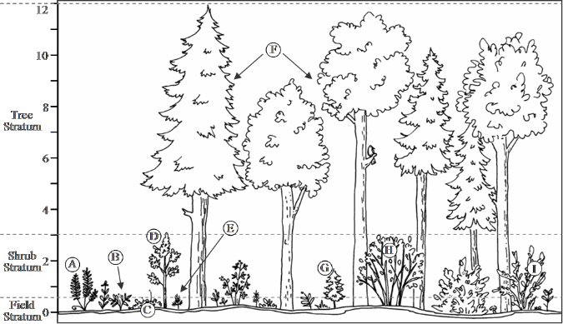

Figure 6. An illustration of strata showing growth forms of individual plants as may be found in a plot (the ground stratum is not delineated). Height is shown in meters. Using the “growth form by size class or layer” option places emphasis on the growth forms first; for example, trees are separated from shrubs and separately the cover of each divided into size classes (e.g. tree overstory versus regeneration).Using the “stratum with growth form” approach places the emphasis on the stratum first, for example, trees and shrubs are placed into stratum, then divided by growth forms (e.g., e.g. tree stratum verus shrub stratum, with the shrub stratum then divided into tree growth forms and shrub growth forms). Figure from Jennings et al. (2009).

Plot data can also be collected at varying levels of intensity (similar to plants specimens, where a specimen may be herbarium quality if it includes flowers, fruits, leaves and stems, or simply of validation quality, when only leaves and stems are collected to help verify identification). Plots can either be detailed classification plots (containing full floristic, growth form/strata, structural, and environmental site information), suitable for rigorous analyses, or they can be validation or occurrence plots (containing dominant species and structure by strata, with cover or other measures of abundance, such as biomass, and basic environmental description), useful for verifying or confirming the type. See below (Section below on Inventory XXXX) for further guidance on plot data collection.

*Type Concepts – the characteristics used to define a vegetation type*

Plot data contain a core set of information for defining vegetation types, includinggrowth forms and structure, floristics, ecological and biogeographical variables. The definition of a vegetation type is summarized by what is often called the “*characteristic species combinations*,” including a) diagnostic combinations of species (character and differential species), b) constant species, and c) dominant species (Westhoff and van der Maarel 1973, Chytrý and Tichý 2003). For the USNVC, this is extended to include characteristic growth forms. The characteristic species and growth form combinations are considered a strong indicator of bioclimatic, biogeographic, geo-edaphic, and successional conditions, but these relationships should be tested against independent ecological data.

*Mapping*

The USNVC standard presented here does not directly provide criteria for vegetation mapping; that is a separate and well treated science (e.g., Küchler and Zonneveld 1988Alexander and Millington 2000, Tart et al. 2005￼by this classification can indeed be mapped and can be used as the basis for mapping patterns of land cover or ecosystem types, subject to limitations of scale, resolution, and inferential mapping technology. Excellent examples of such mapping include the National Park Service maps (Fig. 7). In addition, species distributions can be mapped or modelled with this classification, where they have a known tight relationship with a particular vegetation type. vegetation type.

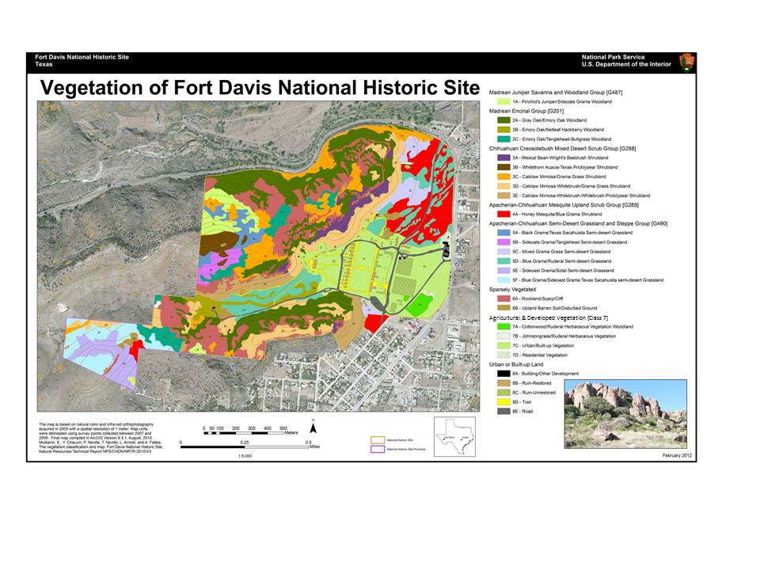

FIGURE 7. Vegetation and land-cover map based on USNVC concepts for the Fort Davis Historic Site, Texas (Muldavin et al. 2012); concepts are at the group and nested association levels for natural and ruderal vegetation and at the class level for cultural vegetation.

* + 1. Principles 7 - 8: The Ecological Vegetation Hierarchy.

*Organization of the Hierarchy*

As noted above, the classification distinguished two broad categories of vegetation: “[Natural](http://usnvc.org/data-standard/natural-vegetation-classification/) Vegetation,” for plant communities primarily influenced by ecological factors, and “[Cultural](http://usnvc.org/data-standard/cultural-vegetation-classification/) Vegetation,” for plant communities shaped by human activity. Separate hierarchical levels are provided for each. Within each hierarchy, consideration is given to the scale of the relationships between vegetation patterns and the ecological and human processes that affect those patterns. At both broad and fine-grained scales, the classification adopts traditional, widely shared concepts, with international terminology that often dates to the early 1900s (e.g. formation, division, alliance, association), but unites these concepts into an effective, coherent hierarchical system based on the EcoVeg approach (Faber-Langendoen et al. 2014).

Natural Vegetation Hierarchy

In the **Natural hierarchy**, the three top, coarse-grained levels (class, subclass, formation) describe major growth form and structural categories on a global scale, such as tropical forest, warm desert, and temperate grassland (Table 2, Fig. 8). The middle levels (division, macrogroup, group) reflect distinctive combinations of species and growth forms in the context of regional to continental scale climate, geology, and water cycles, and disturbance patterns of fire, wind, and flood. Mid-levels include ecosystem categories familiar to ecologists, like Caribbean mangrove forest, Great Basin sagebrush steppe, or elevational and moisture patterns of Southern Rocky Mountain forests (Fig. 9). The composition of species largely defines the lowest, most fine-grained levels (alliance, association), distinguishing, for example, between big sagebrush types or various kinds of dry ponderosa pine types.

TABLE 2. Levels, definition and example of the hierarchy for natural vegetation. The name of the level can be added to the type name for clarity, where needed.

|  |  |  |  |
| --- | --- | --- | --- |
| **Natural Hierarchy** | | **Definition** | **Example** |
| Upper | L1 – Formation Class | A vegetation type defined by broad combinations of dominant general growth forms adapted to basic moisture, temperature, and/or substrate or aquatic conditions. | **Colloquial Name:** Desert & Semi-Desert  **Scientific Name:** Xeromorphic Woodland, Scrub & Herb Vegetation  **Code:** 3. |
| L2 – Formation Subclass | A vegetation type defined by a combination of general dominant and diagnostic growth forms that reflect global mega- or macroclimatic factors driven primarily by latitude and continental position, or that reflect overriding substrate or aquatic conditions. | **Colloquial Name:** Cool Semi-Desert Scrub & Grassland  **Scientific Name:** Cool Semi-Desert Scrub & Grassland  **Code:** 3.B. |
| L3 – Formation | A vegetation type defined by combinations of dominant and diagnostic growth forms that reflect global macroclimatic conditions as modified by altitude, seasonality of precipitation, substrates, and hydrologic conditions. | **Colloquial Name:** Cool Semi-Desert Scrub & Grassland  **Scientific Name:** Cool Semi-Desert Scrub & Grassland  **Code:** 3.B.1. |
| Mid | L4 – Division | A vegetation type defined by combinations of dominant and diagnostic growth forms and a broad set of diagnostic plant species that reflect biogeographic differences in composition and continental differences in mesoclimate, geology, substrates, hydrology, and disturbance regimes. | **Colloquial Name:** Western North American Cool Semi-Desert Scrub & Grassland  **Scientific Name:** *Artemisia tridentata - Atriplex confertifolia / Hesperostipa comata* Cool Semi-Desert Scrub & Grassland  **Code:** D040 |
| L5 – Macrogroup | A vegetation type defined by moderate sets of diagnostic plant species and diagnostic growth forms that reflect biogeographic difference in composition and sub-continental to regional mesoclimate, geology, substrates, hydrology, and disturbance regimes. | **Colloquial Name:** Great Basin-Intermountain Tall Sagebrush Steppe & Shrubland  **Scientific Name:** *Artemisia tridentata - Artemisia tripartita ssp. tripartita - Purshia tridentata* Steppe & Shrubland  **Code:** M169 |
| L6 – Group | A vegetation type defined by a relatively narrow set of diagnostic plant species (including dominants and co-dominants), broadly similar composition, and diagnostic growth forms that reflect regional mesoclimate, geology, substrates, hydrology, and disturbance regimes. | **Colloquial Name:** Intermountain Dry Tall Sagebrush Steppe & Shrubland  **Scientific Name:***Artemisia tridentata ssp. wyomingensis - Artemisia tridentata ssp. tridentata* Steppe & Shrubland  **Code:** G303 |
| Lower | L7 – Alliance | A vegetation type defined by a characteristic range of species composition, habitat conditions, physiognomy, and diagnostic species, typically at least one of which is found in the uppermost or dominant stratum of the vegetation. Alliances reflect regional to subregional climate, substrates, hydrology, moisture/nutrient factors, and disturbance regimes. | **Colloquial Name:** Wyoming Big Sagebrush Dry Shrubland  **Scientific Name:** *Artemisia tridentata ssp. wyomingensis* Dry Steppe & Shrubland  **Code:** A3184 |
| L8 – Association | A vegetation type defined by a characteristic range of species composition, diagnostic species occurrence, habitat conditions and physiognomy. Associations reflect subregional to local topo-edaphic factors of substrates, hydrology, disturbance regimes and climate. | **Colloquial Name:** Wyoming Big Sagebrush / Indian Ricegrass Shrubland  **Scientific Name:** *Artemisia tridentata ssp. wyomingensis / Achnatherum hymenoides* Shrubland  **Code:** CEGL001046 |

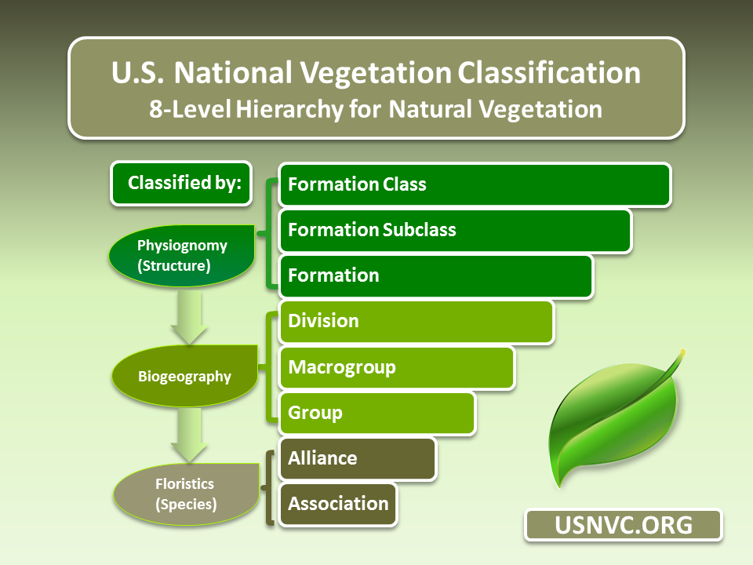

FIGURE 8. Summary of the primary criteria used to define the natural hierarchy levels of the USNVC.

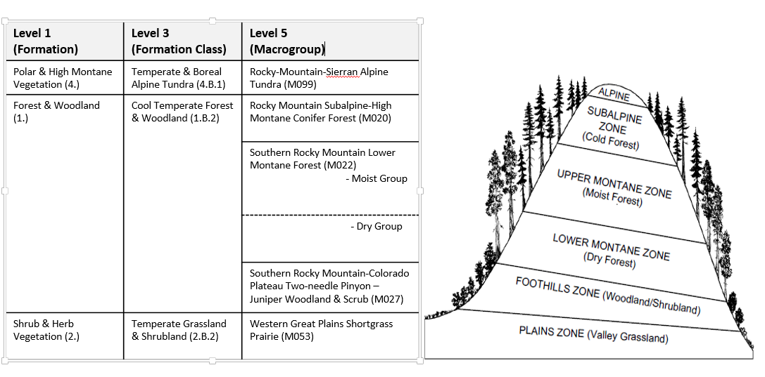

FIGURE 9. Major vegetation types within the southern Rocky Mountains zones in south-central Colorado (Powell 2011). The south slope is shown to the left and north slope to the right. The table on the left shows the corresponding USNVC macrogroup, formation and formation class, corresponding to the major vegetation type of the zone, shown in parentheses (the zones themselves may contain a suite of different vegetation types not shown here).

Cultural Vegetation Hierarchy

The **Cultural vegetation hierarchy**, the top four levels are based on major cultural growth form combinations that reflect types of human manipulation, e.g., agricultural annual row crops, forest plantations, and urban lawns and parks. The two mid-levels are defined by climate, plant taxa, and specifics of human manipulations, such as temperate row crops and hayfields or tropical orchards. The lowest two levels are defined by the dominant set of species, whether for crops or other purposes, e.g., sweet corn or banana crops. Definitions and examples of the cultural hierarchy are provided in FGDC (2008) and Faber-Langendoen et al. (2014).

* + 1. Principle 9: Classification Development - Peer Review and Vegetation Plot Data

The USNVC is supported by the first dynamic federal standard that allows the classification to evolve as information and data about vegetation in the U.S. is refined—and as global change occurs. The version of the USNVC that was released as USNVC v2.0 was based on a variety of data sources, including plots, literature, and expert judgement (see below – Past History). Going forward, each type is preferably described using plot data. These data will lead to important improvements, revisions, and additions to the current set of vegetation types. But the classification needs to be dynamic for another reason: vegetation types will continue to change in response to ongoing changes in the environmental drivers, as well as human drivers that result in “novel” or ruderal ecosystems. These include the spread of invasives, changing coastlines, new pathogens, altered fire and flooding regimes, permafrost levels, and others.

To implement the dynamic content approach, the USNVC partners, through FGDC, have authorized the ESA Panel on Vegetation Classification (hereafter “Panel”) to establish an NVC Review Board. The Panel represents the expertise of professional ecologists spanning academic, agency, and non-governmental sectors, and acts as a forum for debate on scientific issues relating to vegetation ecology and taxonomy (esa.org/panel). The NVC Review Board, consisting of an Editor-in-Chief, Regional Editors and Associate Editors, oversees the review process. Authors may submit proposed updates to the Board, much like articles are peer-reviewed for publication in a journal. However, unlike a journal, the Panel is also responsible for ensuring that changes to types are coordinated among existing types in the database, so that clear boundaries between type concepts are maintained. For example, if a set of sagebrush types are changed, those changes need to be coordinated with closely related pinyon-juniper or grassland types. An USNVC website will host the *National Vegetation Classification Proceeding,* where all accepted changes from peer review will be published.

To support this process, the USNVC partners are committed to a series of tools that will both improve the USNVC and make it continually accessible to the users. These tools include a) an USNVC classification database (currently NatureServe’s Biotics datatabase) and website publication (usnvc.org) that contain the most recent authoritative version of the USNVC, b) support for publicly accessible vegetation plot databases, with VegBank (vegbank.org) as the exemplar for such databases (Peet et al. 2012), c) a peer review tool, whereby authors can submit editorial and peer-review submissions (to be made available in the near future), and d) a publication process for all types that are approved (the USNVC Proceedings, see above). The USNVC partners continue to work on funding and implementation plans that will advance these core activities of the USNVC.

The USNVC partners have agreed that, to provide some level of stability to the users, types at levels 1-5 (formation class to macrogroup) will only change, at most, every five years (though editorial edits may be made to these levels). Lower level USNVC types, levels 6-8, (group, alliance, association) are updated approximately annually, as proposals come in and are accepted. All updates are posted on usnvc.org.

*Past History*

The initial development of the USNVC vegetation types that led to the USNCV 2.0 in 2016 occurred in a series of steps. The lowest floristic units, alliance and association, were initially drafted using the original 1997 hierarchy (FGDC 1997, Grossman et al. 1998). When the revised hierarchy was developed, the associations and alliances were largely retained (though alliances went through a series of revision to better match their concepts with the new hierarchy), and both mid and upper level concepts were then developed. Pilot concepts were developed by a Hierarchy Revisions Working Group (HRWG) prior to the release of the 2008 standard, in order to ensure that the new approach was scientifically sound and workable (the work of the HRWG is documente in Faber-Langendoen et al. 2016). Then a series of concepts were drafted and refined and peer reviewed across all levels by experts among the USNVC partners over the next four to six years, as explained in Franklin et al. (2012), leading to the first, full release in 2016.

* + 1. Current Content

What is the current status of USNVC- numbers of units, where it is served on-line. (in development) msr added some text and a table

All USNVC type descriptions across all eight levels of the hierarchy are now readily available through a web database ([www.usnvc.org](http://www.usnvc.org)), which, in February of 2016, released the first official version 2.0 of the USNVC. Database content and database tools are managed by staff from NatureServe, the U.S. Geological Survey and the U.S. Forest Service. At this time (2016), the lower 48 states have completed an initial set of types for all 8 levels of the hierarchy. Development of types in Alaska, Hawaii and U.S. territories in the Caribbean and elsewhere are less complete, especially at the alliance and association level (Tables 3, 4). The number of types per western state is shown in Table 5.

|  |  |  |  |  |  |
| --- | --- | --- | --- | --- | --- |
| **TABLE 3. Status of the USNVC Natural Vegetation Hierarchy, in USNVC 2.0 (February 2016).** | | | | | |
| **Upper Levels** | | | | | |
| **Formation Class** | Concepts & descriptions written by the Hierarchy Revisions Working Group (HRWG), reviewed by ESA Panel and international experts.  *Completed FY2016 (Faber-Langendoen et al. 2016)* | | | | |
| **Formation Subclass** |
| **Formation** |
|  | Conterminous U.S. | | Alaska | Hawai’i | Caribbean |
| **Middle Levels** | | | | | |
| **Division** | Concepts & descriptions written by HRWG and ESA Peer Review Board Regional Associate Editors. *Completed FY2016* | | | | |
| **Macrogroup** | Concepts & descriptions completed by USNVC partners; Reviewed by ESA panel  *Completed FY2015* | Concepts drafted; by USNVC partners; Reviewed by ESA Panel.  *Revisions in progress* | | Concepts drafted by USNVC partners;  **Descriptions needed.** | Concepts drafted by NatureServe; **Descriptions needed.** |
| **Group** | Concepts & Descriptions drafted by USNVC partners; Reviewed by ESA Panel;  *Completed FY2016* | Concepts drafted by USNVC partners and Alaska Heritage Program; Reviewed by ESA Panel; *Revisions in progress* | | Concepts & Descriptions completed by USNVC partners;  *Completed 2016.* | Concepts drafted by USNVC partners; *Completed 2016* |
| **Lower Levels** | | | | | |
| **Alliance** | Concepts & Descriptions completed by NatureServe;  Reviewed by ESA Panel;  *Completed FY2016* | Concepts in draft form by Alaska Heritage Program;  **Review and integration with USNVC needed.** | | Concepts incomplete;  **Review and integration work needed.** | Concepts incomplete; **Review and integration work needed.** |
| **Association** | Concepts & Descriptions completed by NatureServe, Screening criteria developed by ESA Panel, applied by NatureServe.  *Completed FY2016* | Concepts in draft form by Alaska Heritage Program;  **Review and integration with USNVC needed.** | | Concepts and Descriptions drafted by state partners;  **Review and integration with USNVC needed**. | Concepts incomplete; **integration work needed.** |

TABLE 4. Current count of natural vegetation within the U.S., from USNVC 2.0 (February 2016).

|  |  |
| --- | --- |
| **Level** | **USNVC** |
| Class | 6 |
| Subclass | 15 |
| Formation | 32 |
| Division | 69 |
| Macrogroup | 183 |
| Group | 426 |
| Alliance | 1263* (lower 48 only) |
| Association | 6168* (lower 48 only) |

TABLE 5. Current number of types in western, lower 48, states, from USNVC 2.0 (February 2016).

|  |  |  |  |  |
| --- | --- | --- | --- | --- |
| **state** | **Associations** | **Alliances** | **Groups** | **Macrogroups** |
| AZ | 540 | 184 | 60 | 32 |
| CA | 983 | 367 | 100 | 51 |
| CO | 827 | 205 | 71 | 35 |
| ID | 660 | 165 | 55 | 23 |
| MT | 618 | 201 | 70 | 33 |
| NM | 626 | 190 | 72 | 39 |
| NV | 515 | 189 | 71 | 33 |
| OR | 884 | 254 | 97 | 43 |
| UT | 683 | 172 | 57 | 28 |
| WA | 721 | 210 | 73 | 39 |
| WY | 605 | 188 | 78 | 42 |
| Total,  western states | 3579 | 678 | 174 | 73 |

* + 1. Publications and Products

Multiple products, websites, access to descriptions, relevant reports and papers. (in development). msr did not get to this section

## Websites

U.S. only: usnvc.org

North America: natureserve.org/explorer

## Publications [incomplete]

De Cáceres, M., Chytrý, M., Agrillo, E., Attorre, F., Botta-Dukát, Z., Capelo, J., Czúcz, B., Dengler, J., Ewald, J., Faber-Langendoen, D., Feoli, E., Franklin, S. B., Gavilán, R., Gillet, F., Jansen, F., Jiménez-Alfaro, B., Krestov, P., Landucci, F., Lengyel, A., Loidi, J., Mucina, L., Peet, R. K., Roberts, D. W., Roleček, J., Schaminée, J. H.J., Schmidtlein, S., Theurillat, J.-P., Tichý, L., Walker, D. A., Wildi, O., Willner, W., Wiser, S. K. 2015. A comparative framework for broad-scale plot-based vegetation classification. Applied Vegetation Science 18:543-560. doi: 10.1111/avsc.12179

ESA Vegetation Classification Panel (S. Franklin, P. Comer, J. Evens, E. Ezcurra, D. Faber-Langendoen, J. Franklin, M. Jennings, C. Josse, C. Lea, O. Loucks, E. Muldavin, R. Peet, S. Ponomarenko, D. Roberts, A. Solomeshch, T. Keeler-Wolf, J. Van Kley, A. Weakley, A. McKerrow, M. Burke, and C. Spurrier. 2015. How a national vegetation classification can help ecological research and management. Frontiers in Ecology and the Environment 13: 185-186 (and supplement).

Faber-Langendoen, D., D.L Tart, and R.H. Crawford. 2009. Contours of the revised U.S. National Vegetation Classification standard. Bulletin of the Ecological Society of America 90:87-93

Faber-Langendoen, D., T. Keeler-Wolf, D. Meidinger, D. Tart, B. Hoagland, C. Josse, G. Navarro, S. Ponomarenko, J.-P. Saucier, A. Weakley, P. Comer. 2014.  EcoVeg: A new approach to vegetation description and classification. Ecological Monographs 84:533-561 (erratum 85:473).

Faber-Langendoen, D., T. Keeler-Wolf, D. Meidinger, C. Josse, A. Weakley, D. Tart, G. Navarro, B. Hoagland, S. Ponomarenko, G. Fults & E. Helmer. 2016*. Classification and Description of World Formation Types*. Gen. Tech. Rep. RMRS-GTR-346. Fort Collins, CO: U.S. Department of Agriculture, Forest Service, Rocky Mountain Research Station. 222 p.

Faber-Langendoen, D., K. Baldwin, T.Keeler-Wolf, D. Meidinger, E. Muldavin, R. K. Peet, C. Josse. 2017.. The EcoVeg Approach in North America: International and U.S. and Canadian National Vegetation Classifications. Phytocoenologia [accepted].

Federal Geographic Data Committee.  2008.  [The National Vegetation Classification Standard, Version 2](https://www.fgdc.gov/standards/projects/FGDC-standards-projects/vegetation/NVCS_V2_FINAL_2008-02.pdf).  FGDC Vegetation Subcommittee.  FGDC-STD-005-2008 (Version 2). pp. 126

Franklin, S., D. Faber-Langendoen, M. Jennings, T. Keeler-Wolf, O. Loucks, A. McKerrow, R.K. Peet, and D. Roberts. 2012. Building the United States National Vegetation Classification. Annali di Botanica 2: 1-9.

Jennings, M.D. 2000. Gap Analysis: Concepts, Methods, and Recent Results. Landscape Ecology 15, 5-20.

Jennings, M.D., D. Faber-Langendoen, O.L. Loucks, R.K. Peet, and D. Roberts. 2009. Standards for associations and alliances of the U.S. National Vegetation Classification. Ecological Monographs 79: 173–199.

Peet, R.K., M.T. Lee, M.D. Jennings, and D. Faber-Langendoen. 2012. VegBank: a permanent, open-access archive for vegetation plot data. Biodiversity & Ecology 4:233-241.

**Summary [**to be updated based on above text**]:**

Since 1997, the Federal Geographic Data Committee Vegetation Subcommittee, chaired by the U.S. Forest Service, provides the mechanism for federal agencies, Ecological Society of America and NatureServe to collaborate on the support of the U.S. National Vegetation Classification. Other key agency support comes from the U.S. Geological Survey, the National Park Service, and the Bureau of Land Management, along with other land management based agencies. The USNVC is supported by a standard that provides the basis for a process for considering, evaluating and acting on proposals for improving the classification. The ESA Vegetation Classification Panel is managing a formal review at each level of the classification. Yet, at all times, a definitive, current list of types will be available in a web database on usnvc.org.  NatureServe and USGS will regularly update the website with the most current content. Users will benefit from the USNVC by having a standard system that they can have confidence in. While no classification will be applicable to all questions, having standards for data collection, analysis and interpretation, and the classification scheme itself, offers ecological and economic advantages to large-scale research, management, and inventory. In addition, having a context for the variety of individual research and management efforts will improve our ability to place all these pieces into a consistent and more productive framework.

**References [incomplete ..**

Arkle, R.S., D. S. Pilliod, S. E. Hanser, M. L. Brooks, J. C. Chambers, J. B. Grace, K. C. Knutson, D. A. Pyke, J. L. Welty, and T. A. Wirth 2014. Quantifying restoration effectiveness using multi-scale habitat models: implications for sage-grouse in the Great Basin. Ecosphere 5:art31. <http://dx.doi.org/10.1890/ES13-00278.1>

Bram, D., M. Most, K. Hymel, and S. Dark. 2015. A shared vision for the California survey of Vegetation. Northridge, CA: Center for Geographical Studies, California State University.

Dunn, L.  J. Lonneker, A. Davidson.  2015.  Great Basin LCC Biodiversity Status and Fire:  An Enhanced Gap Analysis.  Poster Presentation for the Great Basin Consortium Conference. Feb 17-19, 2015, Boise, ID

ESA Vegetation Classification Panel (S. Franklin, P. Comer, J. Evens, E. Ezcurra, **D. Faber-Langendoen**, J. Franklin, M. Jennings, C. Josse, C. Lea, O. Loucks, E. Muldavin, R. Peet, S. Ponomarenko, D. Roberts, A. Solomeshch, T. Keeler-Wolf, J. Van Kley, A. Weakley, A. McKerrow, M. Burke, and C. Spurrier. 2015. How a national vegetation classification can help ecological research and management. Frontiers in Ecology and the Environment 13: 185-186 (and supplement).

Evens, J. and T. Keeler-Wolf. 2014. Vegetation mapping is essential in conserving rare desert plant species and plant communities. *Fremontia* 42:11-14.

Faber-Langendoen D., D.L. Tart, and R.H. Crawford. 2009. Contours of the revised U.S. National Vegetation Classification standard. *Bull Ecol Soc Am* 90: 87–93.

Faber-Langendoen, D., T. Keeler-Wolf, D. Meidinger, *et al.* 2014. EcoVeg: A new approach to vegetation description and classification. *Ecol Monogr*. 84:533-561 (erratum 85:473).

FGDC. 2008. National Vegetation Classification Standard, Version 2 FGDC-STD-005-2008 (version 2). Vegetation Subcommittee, Federal Geographic Data Committee, FGDC Secretariat, U.S. Geological Survey. Reston, VA. 55 pp. + Appendices.

Jennings M.D., D. Faber-Langendoen, O.L. Loucks, *et al.* 2009. Standards for Associations and Alliances of the U.S. National Vegetation Classification. *Ecol Monogr* **79**: 173–199.

Matthews, E.M., R.K. Peet, & A.S. Weakley. 2011. Classification and description of alluvial plant communities of the Piedmont region. North Carolina, U.S.A. *Applied Vegetation* *Science* 14: 485-505.

Muldavin E., Y. Chauvin, P. Neville *et al.* 2012. A vegetation classification and map: Fort Davis National Historic Site. Natural Resource Technical Report NPS/ CHDN/NRTR–2012/639, National Park Service, Fort Collins, Colorado.

Palmquist KA, R.K. Peet, and A.S.Weakley 2014. Changes in plant species richness following reduced fire frequency and drought in one of the most species-rich savannas in North America. *J. Vegetation Sci* **25**: 1426–37.

Peet, R.K., Wentworth, T.R. & White, P.S. 1998. A flexible, multipurpose method for recording vegetation composition and structure. *Castanea* 63: 262-274.

Peet R.K. 2008. A decade of effort by the ESA Vegetation Panel leads to a new federal standard. *Bull Ecol Soc Am* **89**:210–11.

Peet, R.K., M.T. Lee, M.D. Jennings, and D. Faber-Langendoen. 2012. VegBank - a permanent, open-access archive for vegetation-plot data. *Biodiversity Ecol* **4**: 233-241.

Schimel J., and O. Chadwick. 2013. What’s in a name? The importance of soil taxonomy in ecology and biogeochemistry. *Front Ecol Environ* **11**: 405-406.

Shmida, A. 1984. Whittaker’s plant diversity sampling method. *Isr. J. Bot*. 33: 41-46.

Stohlgren, T.J., Bull, K.A. & Otsuki, Y. 1998. Comparison of rangeland vegetation sampling techniques in the central grasslands. *J. Range Manage*. 51: 164-172.

Watts, A. 2016. Updated National Vegetation Classification offers consistency and dynamism. The Forestry Source (April 2016) 21(4):1,8.

Nelson, M. L., K. Brewer, S. J. Solem. Editors.  2015.  [Existing Vegetation Classification, Mapping, and Inventory Technical Guide Version 2.0.](http://www.fs.fed.us/emc/rig/protocols/vegclassmapinv.shtml) Gen. Tech. Rep. WO–90. Washington, DC: U.S. Department of Agriculture Forest Service, Ecosystem Management Coordination Staff. 212 p.

Brown, Karl. 2008. [National Park Service vegetation inventory and use of hybrid approaches to signature development and object oriented tools](https://www.google.com/url?sa=t&rct=j&q=&esrc=s&source=web&cd=1&cad=rja&uact=8&ved=0ahUKEwjPgP7V-8fKAhVCQyYKHTFoAb8QFggcMAA&url=http%3A%2F%2Fwww.asprs.org%2Fa%2Fpublications%2Fproceedings%2Fpecora17%2F0010.pdf&usg=AFQjCNEd9MWrmaBMfuKG1rOfLqSdUvEi_g&bvm=bv.112454388,d.eWE). Pecora 17 Nov. 18-20, 2008. Denver Colorado.

Grossman, D.H., D. Faber-Langendoen, A.S. Weakley, M. Anderson, P. Bourgeron, R. Crawford, K. Goodin, S. Landaal, K. Metzler, K. Patterson, M. Pyne, M. Reid, and L. Sneddon, 1998. International classification of ecological communities: [Terrestrial vegetation of the United States](http://www.natureserve.org/biodiversity-science/publications/terrestrial-vegetation-united-states-volume-ihttp:/). Volume I. The National Vegetation Classification System: development, status and applications. The Nature Conservancy, Arlington VA.

Jennings, Michael D. 1996. Mapping Units: Their Classification and Nomenclature for Gap Analysis Land Cover Data. Scott, J.M., T.H. Tear, and F.W. Davis, editors. 1996. Gap Analysis: A landscape approach to biodiversity planning. American Society for Photogrammetry and Remote Sensing, Bethesda, Maryland. ISBN-1-57083-03603