Michael Lee (Michael_Lee@natureserve.org), March 2018 (updated June 2018)

Unanet can be improved by running user scripts after each page loads.
This can show whether variance is 0 or negative, or if a project is within $100 of balanced, or it can hide extraneous rows in tables.
To do this sort of thing, a tool needs to be embedded in the browser that will run the scripts. This tool is called GreaseMonkey and it’s an add-on for Firefox. Chrome works less well.
If you don’t have Firefox, you can download it here:
https://www.mozilla.org/en-US/firefox/
If you already have Firefox, open Firefox, then copy and paste this link into the web address bar in Firefox:
https://addons.mozilla.org/en-US/firefox/addon/greasemonkey/
Click “+add to Firefox”
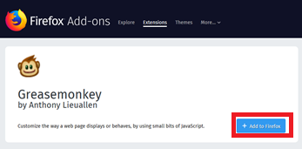
Firefox will want you to confirm you want to add Greasemonkey as an add-on. Click “add.”
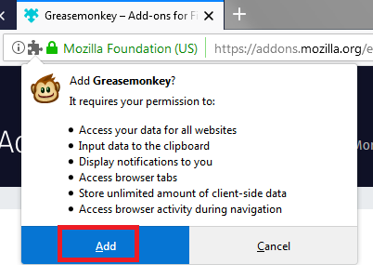
If Greasemonkey installs correctly, you’ll get a home page for showing you how to use Greasemonkey. You can close that. You should see a monkey in the upper right of Firefox:
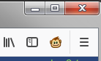
Now you need to add my script does the work to reformat unanet web pages.
To get the script, copy and paste one of these links into Firefox:
If you want CSV exporting functions (any table can be copied as csv):
https://tranxfer.natureserve.org/download/Deleted_Yearly/SE_Office/unanet/UnanetHighlight_GreaseMonkey_v1.4_withCSVExport.user.js
If not, use this one:
https://tranxfer.natureserve.org/download/Deleted_Yearly/SE_Office/unanet/UnanetHighlight_GreaseMonkey_v1.4_noCSVExport.user.js
Firefox senses that you want to make use of the user script. Click the green install button:
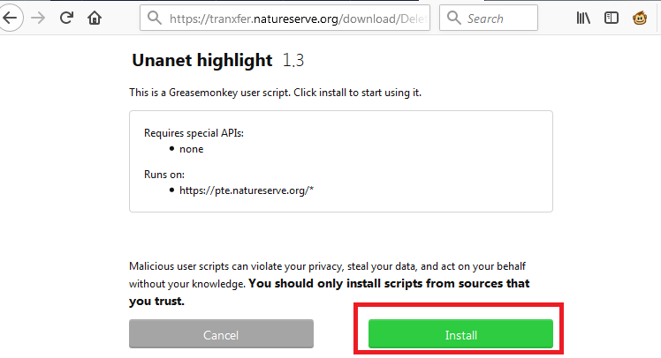
Now when you go to unanet in Firefox, you’ll see highlighting and buttons that allow you to hide rows.
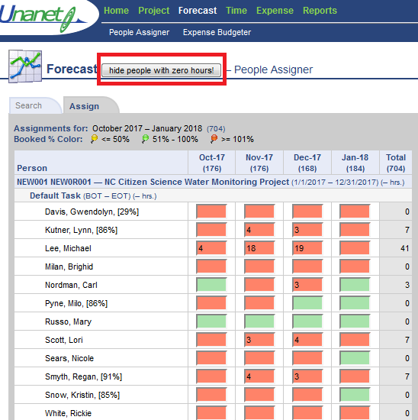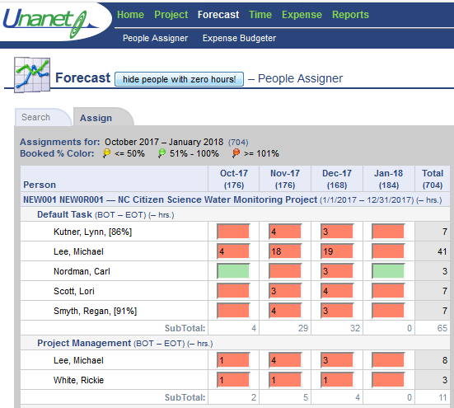
This script works in Chrome too, but you don’t need Greasemonkey, but you have to install the user script each time before you visit unanet. Firefox/Greasemonkey is a once-and-done installation.

